 | 26.9.8 Editors - Properties Editor - Modifiers Properties Tab - Grease Pencil - Deform Modifiers
Table of content
Detailed table of content 1
Deform modifiers 5
Armature 5
Hook 7
Lattice 9
Noise 10
Offset 13
Shrinkwrap 15
Smooth 18
Thickness 20

Detailed table of content

Detailed table of content
Detailed table of content 1
Deform modifiers 5
Armature 5
Apply as Shape Key 5
Save as Shape Key 5
Object 6
Vertex Group 6
Invert 6
Bind to 6
Vertex Groups 6
Bone Envelopes 6
Hook 7
Object 7
Vertex Group 7
Invert 7
Strength 8
Reset 8
Recenter 8
Select 8
Assign 8
Falloff 8
Type 8
Radius 8
Uniform Falloff 8
Influence 8
Layer 8
Invert 8
Pass 8
Invert 8
Material 9
Invert 9
Pass 9
Invert 9
Lattice 9
Object 9
Vertex Group 9
Invert 9
Strength 9
Influence 9
Layer 9
Invert 10
Pass 10
Invert 10
Material 10
Invert 10
Pass 10
Invert 10
Noise 10
Position 10
Strength 10
Thickness 10
UV 10
Noise Scale 10
Noise Offset 11
Noise Seed 11
Randomize 11
Step 11
Influence 11
Layer 11
Invert 11
Pass 11
Invert 11
Material 11
Invert 11
Pass 11
Invert 11
Vertex Group 11
Invert 12
Custom Curve 12
Navigation elements 12
Zoom in and out 12
Tools 12
Reset View 12
Vector Handle 12
Auto Handle 12
Auto Clamped Handle 12
Extend Horizontal 12
Extend Vertical 12
Reset Curve 12
Use Clipping 12
Delete Points 13
Curve window 13
X / Y 13
Offset 13
General Subpanel 13
Location X, Y, Z 13
Rotation X, Y, Z 13
Scale X, Y, Z 13
Advanced Subpanel 13
Mode 13
Random 13
Layer 13
Stroke 14
Material 14
Offset 14
Rotation 14
Scale 14
Uniform Scale 14
Seed 14
Layer Step 14
Layer Offset 14
Stroke Step 14
Stroke Offset 14
Material Step 14
Material Offset 14
Influence subpanel 15
Layer 15
Invert 15
Pass 15
Invert 15
Material 15
Invert 15
Pass 15
Invert 15
Vertex Group 15
Invert 15
Shrinkwrap 15
Wrap Method 16
Nearest Surface Point + Target Normal Project 16
Snap Mode 16
Target 16
Project 16
Snap Mode 16
Limit 16
Subdivision Levels 16
Axis 16
Negative/Positive 16
Face Cull 17
Invert Cull 17
Target 17
Auxiliary Target 17
Nearest Vertex 17
Target 17
Offset 17
Smooth factor 17
Repeat 17
Vertex Group 17
Invert 17
Influence subpanel 17
Layer 17
Invert 17
Pass 18
Invert 18
Material 18
Invert 18
Pass 18
Invert 18
Vertex Group 18
Invert 18
Smooth 18
Mode 18
Position 18
Strength 18
Thickness 18
UV 19
Factor 19
Repeat 19
Influence 19
Layer 19
Invert 19
Pass 19
Invert 19
Material 19
Invert 19
Pass 19
Invert 19
Vertex Group 19
Invert 19
Custom Curve 20
Navigation elements 20
Zoom in and out 20
Thickness 20
Uniform Thickness 20
Thickness Factor 20
Weighted 20
Influence 20
Layer 20
Invert 20
Pass 20
Invert 20
Material 21
Invert 21
Pass 21
Invert 21
Vertex Group 21
Invert 21
Custom Curve 21
Navigation elements 21
Zoom in and out 21
Tools 21
Reset View 21
Vector Handle 21
Auto Handle 22
Auto Clamped Handle 22
Extend Horizontal 22
Extend Vertical 22
Reset Curve 22
Use Clipping 22
Delete Points 22
Curve window 22
X / Y 22

Deform modifiers
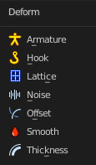

Armature
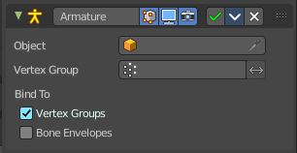
An armature system allows to deform objects accurately by posing bones. The Armature modifier contains the armature settings at the mesh end.
This modifier gets created automatically when you parent a grease pencil to an armature.

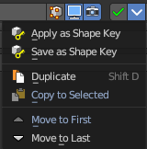
The armature modifier has two extra entries in the dropdown menu in the header.

Apply as Shape Key
Apply the modifier as a new shapekey to the mesh, and remove the armature modifier.

Save as Shape Key
Apply the modifier as a new shapekey to the mesh, but keep the armature modifier.

Object
The name of the armature object used by this modifier.

Vertex Group
A vertex group of the object, which weights will be used to determine the influence of this modifier’s results when mixing it with the results from other Armature ones.
This is only of use when having at least two of these modifiers on the same object, with Multi Modifier activated.

Invert
Inverts the influence set by the vertex group.

Bind to

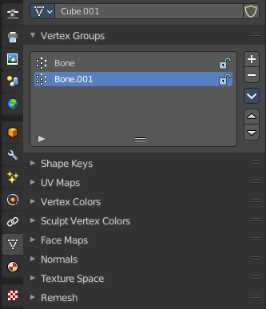
Vertex Groups
Meshes and lattices only. Use Vertex groups for deforming the mesh. A bone named “forearm”, will only affect the vertices in the “forearm” vertex group. The influence of one bone on a given vertex is controlled by the weight of this vertex in the relevant group.
The vertex groups are located in the Object Data Properties in the Properties editor.

Bone Envelopes
Use the Bone envelopes to deform vertices or control points near them, defined by each bone’s envelope radius and distance.
When envelopes are disabled, Blender uses the set of existing vertex group names to determine which bones influences what mesh part.
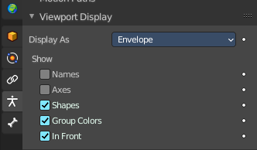
Bone envelopes display can be turned on in the Viewport Display panel in the Object Data properties tab in the Properties Editor. Display as ...

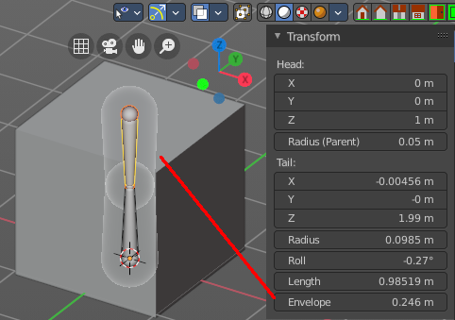
And can be adjusted in the Transform panel in the sidebar of the 3D View, in Edit mode.

Hook
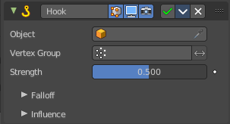
The Hook modifier is used to deform a mesh, curve or lattice by another object. When you move this hook object, then it pulls vertices or control points with it.
Assigning the hook object to specific vertices of the target object is done in Edit mode. The modifier shows a set of buttons then.
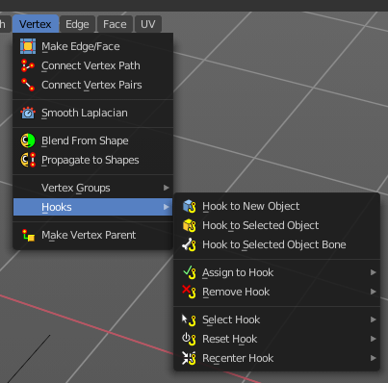
This modifier is automatically created when you add a Hook from the Hooks menu in the Edge menu in edit mode.
Some settings just exists in Edit mode.
Warning! The Hook Modifier stores vertex indices from the original mesh to determine what to affect. Modifiers that generate geometry, like Subdivision Surface, should always be put after the Hook modifier in the stack. Otherwise, the generated geometry can‘ t be affected by the hook’s influence.

Object
The name of the object to hook vertices to.

Vertex Group
Allows you to define the influence per vertex.

Invert
Inverts the influence of the selected vertex group.

Strength
Adjust this hooks influence on the vertices.

Reset
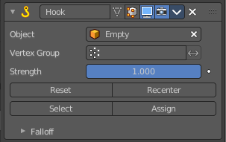
In Edit mode. Recalculate and clear the offset transform of the hook.

Recenter
In Edit mode. Set the hook center to the 3D cursor position.

Select
In Edit mode. Select the vertices affected by this hook.

Assign
In Edit mode. Assigns selected vertices to this hook.

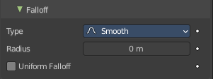
Falloff

Type
This can be used to adjust the kind of influence curve that the hook has on the mesh. You can also define a custom curve to get a much higher level of control.

Radius
The size of the hooks influence.

Uniform Falloff
Compensate non uniform scale, and use a uniform falloff.

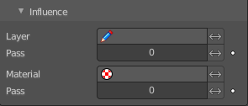
Influence

Layer
Restricts the effect only to one layer or to any layers that share the same pass index. Click to pick the layer that you want to use.

Invert
Inverts the influence.

Pass
The layer pass index.

Invert
Inverts the influence.

Material
Restricts the effect only to material that share the same material or pass index. Click to pick the material that you want to use.

Invert
Inverts the influence.

Pass
The material pass index.

Invert
Inverts the influence.

Lattice
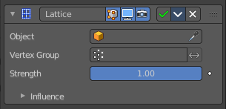
The Lattice modifier deforms the base object by the shape of a Lattice object. It can be used at meshes, curves, surfaces, text, lattices and even particles.
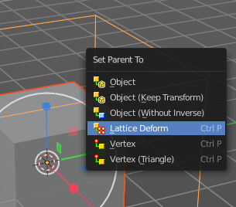
A Lattice modifier with valid settings can be added by selecting the object, holding down shift, select the target lattice object, and then choose Lattice Deform in the Parent menu.
Note! When you want to use a lattice to deform particles, then you need to place the Lattice modifier after the Particle System modifier.

Object
The Lattice object that deforms the base object.

Vertex Group
Limit the modifier’s effect to a vertex group of the base mesh.

Invert
Inverts the influence of the selected vertex group.

Strength
A factor to control blending between original and deformed vertex positions.

Influence

Layer
Restricts the effect only to one layer or to any layers that share the same pass index. Click to pick the layer that you want to use.

Invert
Inverts the influence.

Pass
The layer pass index.

Invert
Inverts the influence.

Material
Restricts the effect only to material that share the same material or pass index. Click to pick the material that you want to use.

Invert
Inverts the influence.

Pass
The material pass index.

Invert
Inverts the influence.

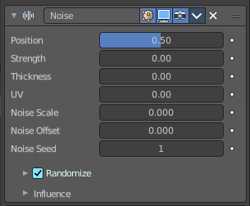
Noise
The Noise Modifier adds noise to make the grease pencil line unstable and noisy.

Position
Strength of the noise effect over the point location.

Strength
Strength of the noise effect over the point strength (opacity).

Thickness
Strength of the noise effect over the point thickness.

UV
Strength of the noise effect over the point UV rotation.

Noise Scale
Control the noise frequency scale.

Noise Offset
Offset the noise along the stroke.

Noise Seed
Add a random seed.

Randomize
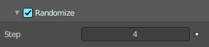
Use a random value over time.

Step
Number of frames before using a new random value.

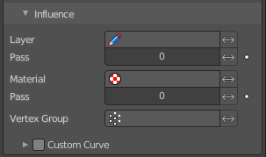
Influence

Layer
Restricts the effect only to one layer or to any layers that share the same pass index. Click to pick the layer that you want to use.

Invert
Inverts the influence.

Pass
The layer pass index.

Invert
Inverts the influence.

Material
Restricts the effect only to material that share the same material or pass index. Click to pick the material that you want to use.

Invert
Inverts the influence.

Pass
The material pass index.

Invert
Inverts the influence.

Vertex Group
Limit the influence to a vertex group.

Invert
Inverts the influence.

Custom Curve
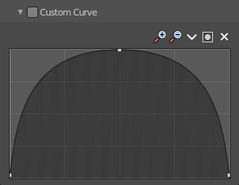
Use a custom curve to define the noise along the strokes.

Navigation elements
The navigation elements at the top are described from left to right.

Zoom in and out
The two buttons with the magnifying glass at it zooms in and out in the curve window.

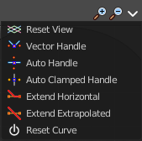
Tools
Tools is a menu where you can find some curve related tools.

Reset View
Resets the curve windows zoom.

Vector Handle
Set handle type to Vector.

Auto Handle
Set handle type to Auto.

Auto Clamped Handle
Set handle type to Auto Clamped.

Extend Horizontal
Extend the curve points horizontal before the first curve point and after the last curve point.

Extend Vertical
Extend the curve points vertical before the first curve point and after the last curve point.

Reset Curve
Resets the curve to the initial shape.

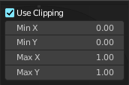
Use Clipping
Clipping options. Set up clipping for the stroke.

Delete Points
Deletes selected curve points.

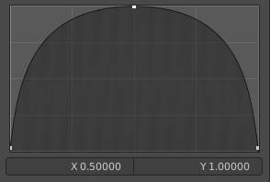
Curve window
Tweak and adjust the falloff curve by clicking at a curve point and dragging it around.
Double click adds a new point.
Holding down ctrl activates temporary snapping.
Holding down shift enables slower movement, which allows more accurate setting.

X / Y
The position of the currently selected curve point.

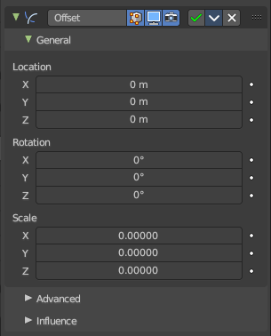
Offset
The Offset Modifier changes the strokes location, rotation or scale, starting from the object origin.

General Subpanel

Location X, Y, Z
Sets strokes location offset from its object origin.

Rotation X, Y, Z
Sets strokes rotation.

Scale X, Y, Z
Sets strokes scale.

Advanced Subpanel

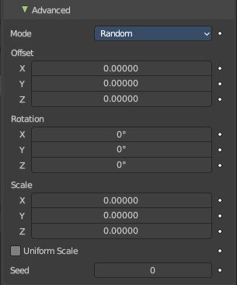
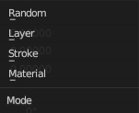
Mode

Random
Randomize Stroke Offset.

Layer
Offset Layers by the same factor.

Stroke
Offset stroke by the same factor based on stroke draw order.

Material
Offset materials by the same factor.

Offset
Randomize the offset in x y and z axis.

Rotation
Randomize the rotation in x y and z angle.

Scale
Randomize the size in x y and z axis.

Uniform Scale
Mode random. Use the same random seed for each scale axis for a uniform scale.

Seed
Mode Random. The random seed for the uniform scale.

Layer Step
Mode Seed. Number of elements that will be grouped.

Layer Offset
Mode Seed. Offset Starting Point.

Stroke Step
Mode Stroke. Number of elements that will be grouped.

Stroke Offset
Mode Stroke. Offset Starting Point.

Material Step
Mode Material. Number of elements that will be grouped.

Material Offset
Mode Material. Offset Starting Point.

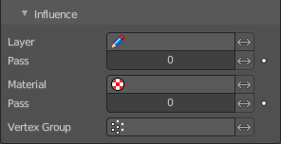
Influence subpanel

Layer
Restricts the effect only to one layer or to any layers that share the same pass index. Click to pick the layer that you want to use.

Invert
Inverts the influence.

Pass
The layer pass index.

Invert
Inverts the influence.

Material
Restricts the effect only to material that share the same material or pass index. Click to pick the material that you want to use.

Invert
Inverts the influence.

Pass
The material pass index.

Invert
Inverts the influence.

Vertex Group
Limit the influence to a vertex group.

Invert
Inverts the influence.

Shrinkwrap
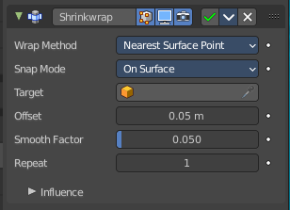
Shrinks the geometry to the surface of another object.

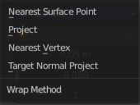
Wrap Method
The method to determine the nearest point on the target’s surface for each vertex of the object.

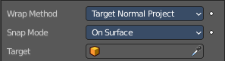
Nearest Surface Point + Target Normal Project
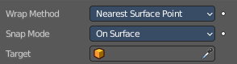
Nearest Surface Point selects the nearest point at the surface. Additionally, Target Normal Project tries to match the interpolated normals of the surface.

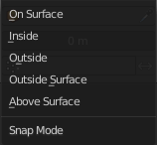
Snap Mode
How the vertex snaps to the surface. The methods should be self explaining.

Target
The target mesh to shrink to.

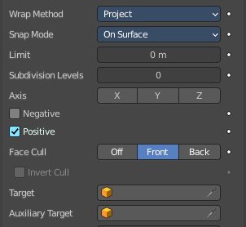
Project
Projects all vertices along a chosen axis until they hit the surface of the target object.
Vertices that never hits the surface are not calculated.

Snap Mode
How the vertex snaps to the surface. The methods should be self explaining.

Limit
A distance limit between original vertex and surface. If the distance is larger than this limit vertex would not be projected onto the surface.

Subdivision Levels
This applies a (temporary) Catmull-Clark subdivision to the modified object’s geometry, before computing the wrap.

Axis
Along which local axis of the modified object the projection is done. These options can be combined with each other, yielding a “median axis” of projection. If none are selected, the normal direction is used.

Negative/Positive
This allows you to select the allowed direction(s) of the shrink along the selected axis. If both options are enabled, both ways are evaluated and the closest hit is selected.

Face Cull
Allows you to prevent any projection over the “front side” or the “back side” of the target’s faces. The “side” of a face is determined by its normal.

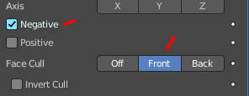
Invert Cull
When projecting in the negative direction then invert culling.
You need to have negative ticked and face cull either front or back to set this property active.

Target
The target mesh to shrink to.

Auxiliary Target
An additional object to project to.

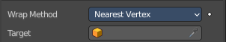
Nearest Vertex

Target
The target mesh to shrink to.

Offset
An offset distance to keep to the target surface.

Smooth factor
Amount of smoothing to apply

Repeat
Number of steps to apply smooth.

Vertex Group
Restrict the affected vertices to a vertex group.

Invert
Inverts the influence of the selected vertex group.

Influence subpanel

Layer
Restricts the effect only to one layer or to any layers that share the same pass index. Click to pick the layer that you want to use.

Invert
Inverts the influence.

Pass
The layer pass index.

Invert
Inverts the influence.

Material
Restricts the effect only to material that share the same material or pass index. Click to pick the material that you want to use.

Invert
Inverts the influence.

Pass
The material pass index.

Invert
Inverts the influence.

Vertex Group
Limit the influence to a vertex group.

Invert
Inverts the influence.

Smooth
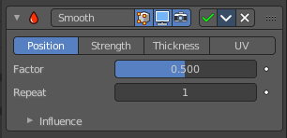
The Smooth modifier smoothens a stroke.

Mode
What elements to affect.

Position
Affects the position of the point.

Strength
Affects the color strength of the point

Thickness
Affects the thickness of the point.

UV
Affects the uv rotation factor of the point.

Factor
The smoothing amount. Higher values will increase the effect. Values outside expected range (above 1.0 or below 0.0) will distort the mesh.

Repeat
The number of smoothing iterations.

Influence

Layer
Restricts the effect only to one layer or to any layers that share the same pass index. Click to pick the layer that you want to use.

Invert
Inverts the influence.

Pass
The layer pass index.

Invert
Inverts the influence.

Material
Restricts the effect only to material that share the same material or pass index. Click to pick the material that you want to use.

Invert
Inverts the influence.

Pass
The material pass index.

Invert
Inverts the influence.

Vertex Group
Limit the influence to a vertex group.

Invert
Inverts the influence.

Custom Curve
Use a custom curve to define the noise along the strokes.

Navigation elements
The navigation elements at the top are described from left to right.

Zoom in and out
The two buttons with the magnifying glass at it zooms in and out in the curve window.

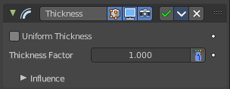
Thickness
The Thickness Modifier change the stroke points thickness.

Uniform Thickness
When enabled, makes the thickness equal for the entire strokes.

Thickness Factor
Value to add or subtract to the actual points thickness.

Weighted
Use weight to modulate effect.

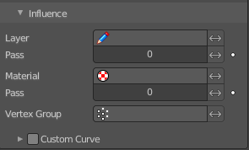
Influence

Layer
Restricts the effect only to one layer or to any layers that share the same pass index. Click to pick the layer that you want to use.

Invert
Inverts the influence.

Pass
The layer pass index.

Invert
Inverts the influence.

Material
Restricts the effect only to material that share the same material or pass index. Click to pick the material that you want to use.

Invert
Inverts the influence.

Pass
The material pass index.

Invert
Inverts the influence.

Vertex Group
Limit the influence to a vertex group.

Invert
Inverts the influence.

Custom Curve
Use a custom curve to define the noise along the strokes.

Navigation elements
The navigation elements at the top are described from left to right.

Zoom in and out
The two buttons with the magnifying glass at it zooms in and out in the curve window.

Tools
Tools is a menu where you can find some curve related tools.

Reset View
Resets the curve windows zoom.

Vector Handle
Set handle type to Vector.

Auto Handle
Set handle type to Auto.

Auto Clamped Handle
Set handle type to Auto Clamped.

Extend Horizontal
Extend the curve points horizontal before the first curve point and after the last curve point.

Extend Vertical
Extend the curve points vertical before the first curve point and after the last curve point.

Reset Curve
Resets the curve to the initial shape.

Use Clipping
Clipping options. Set up clipping for the stroke.

Delete Points
Deletes selected curve points.

Curve window
Tweak and adjust the falloff curve by clicking at a curve point and dragging it around.
Double click adds a new point.
Holding down ctrl activates temporary snapping.
Holding down shift enables slower movement, which allows more accurate setting.

X / Y
The position of the currently selected curve point.

